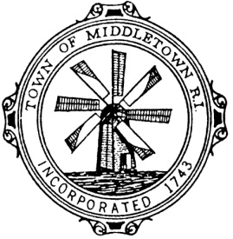
Middletown Police Department
Administrative (401)-846-1144
Emergency (401) 846-1104
Records (401) 849-3131
Detectives (401) 846-0029
Fax (401) 846-0175
123 Valley Road
Middletown, Rhode Island 02842-5397

William D. Kewer
Chief of Police

FOR IMMEDIATE RELEASE: CONTACT: Capt. Jason Ryan
September 2, 2021 (401) 846-1144 ext. 7004

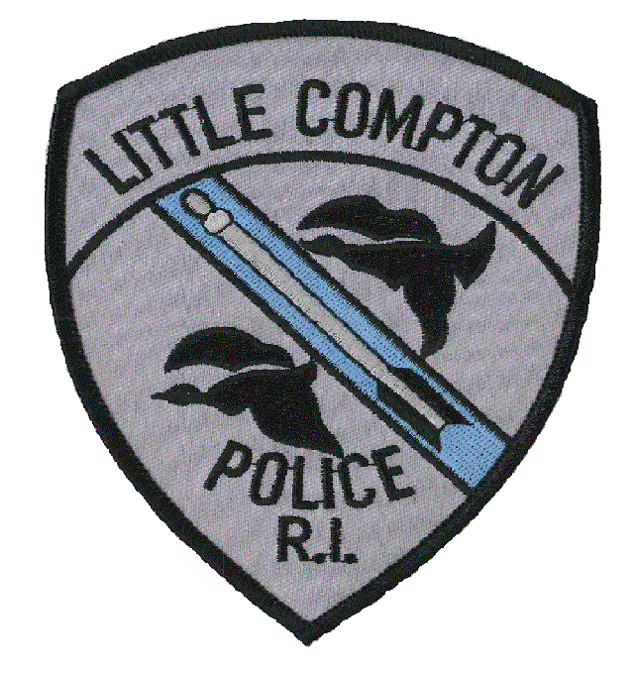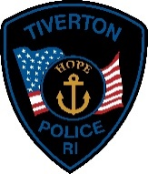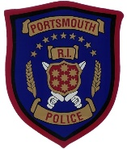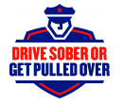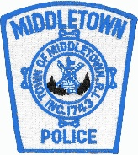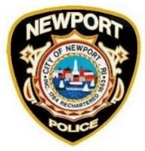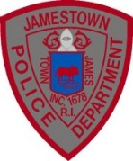

Newport County Police Departments Announce Labor Day Weekend DUI Enforcement Campaign

NEWPORT COUNTY - This Labor Day weekend, ALL Newport County Police Departments, including Middletown, Newport, Portsmouth, Jamestown, Tiverton and Little Compton, in cooperation with the Rhode Island Office on Highway Safety and the Rhode Island Police Chiefs’ Association, will be conducting enhanced DUI patrols.

This campaign will begin on Friday, Sept. 3 and continue through Labor Day on Monday, Sept. 6. According to the National Highway Safety Transportation Administration (NHSTA) statistics, during the 2019 Labor Day Weekend, there were 451 traffic related fatalities across the United States. Of those fatalities, 45% involved a driver who had been driving under the influence. The goal of this campaign is to educate the public on the dangers of driving under the influence and to reduce the number of motor vehicle crashes attributed to impaired drivers.

All Newport County Police Departments will work in collaboration, with some departments teaming up officers throughout the holiday weekend and performing saturation patrols in an effort to detect impaired drivers. In addition, this DUI initiative will utilize the Providence Police Department’s Breath Alcohol Testing (B.A.T.) Mobile Unit. The B.A.T. Mobile allows officers to have centralized location to process all DUI arrests, which includes the administering of breathalyzer tests. Departments will also have trained Drug Recognition Experts (DRE’s) on hand to further evaluate drivers who may be operating while under the influence of a controlled substance other than alcohol.

“Newport County Police Departments will have a strong presence on all roads over the Labor Day weekend.” said Middletown Police Chief William Kewer. “We encourage members of the public to call 911 from their cell phone if they observe aggressive or erratic drivers. We would also like to wish everyone a happy Labor Day, and hope they have an enjoyable and SAFE holiday weekend.”

Be Smart and Be Responsible.

** END **

